**Exercise 1: Control Structures**

**Step 1: Create the tables**

CREATE TABLE customers (

customer_id NUMBER PRIMARY KEY,

customer_name VARCHAR2(50),

age NUMBER,

balance NUMBER,

isvip VARCHAR2(5)

);

CREATE TABLE loans (

loan_id NUMBER PRIMARY KEY,

customer_id NUMBER,

interest_rate NUMBER,

due_date DATE,

FOREIGN KEY (customer_id) REFERENCES customers(customer_id)

);

**Step 2: Insert sample data**

INSERT INTO customers VALUES (1, 'John', 65, 9500, 'FALSE');

INSERT INTO customers VALUES (2, 'Alice', 55, 11000, 'FALSE');

INSERT INTO customers VALUES (3, 'Mark', 70, 5000, 'FALSE');

INSERT INTO loans VALUES (101, 1, 10, SYSDATE + 10);

INSERT INTO loans VALUES (102, 2, 12, SYSDATE + 40);

INSERT INTO loans VALUES (103, 3, 11, SYSDATE + 20);

COMMIT;

SELECT * FROM CUSTOMERS;

CUSTOMER_ID CUSTOMER_NAME AGE BALANCE ISVIP

-------------------- -------------------------- -------- ---------------- ----------

1 John 65 9500 FALSE

2 Alice 55 11000 FALSE

3 Mark 70 5000 FALSE

SELECT * FROM LOANS;

LOAN_ID CUSTOMER_ID INTEREST_RATE DUE_DATE

---------- ----------- ------------- ---------

101 1 10 08-JUL-25

102 2 12 07-AUG-25

103 3 11 18-JUL-25

**Scenario 1:** The bank wants to apply a discount to loan interest rates for customers above 60 years old.

* + **Question:** Write a PL/SQL block that loops through all customers, checks their age, and if they are above 60, apply a 1% discount to their current loan interest rates.

SET SERVEROUTPUT ON;

DECLARE

CURSOR loan_cursor IS

SELECT L.CUSTOMER_ID, L.INTEREST_RATE

FROM LOANS L

JOIN CUSTOMERS C ON L.CUSTOMER_ID = C.CUSTOMER_ID

WHERE C.AGE > 60;

BEGIN

FOR rec IN loan_cursor LOOP

UPDATE LOANS

SET INTEREST_RATE = INTEREST_RATE - 1

WHERE CUSTOMER_ID = rec.CUSTOMER_ID;

END LOOP;

COMMIT;

DBMS_OUTPUT.PUT_LINE('Interest rates updated for customers above 60.');

END;

/

* SELECT * FROM LOANS;

**OUPUT:**

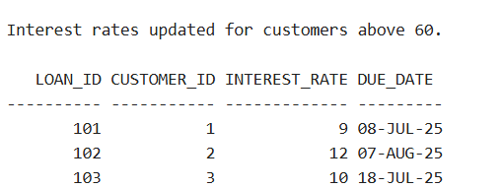

**Scenario 2:** A customer can be promoted to VIP status based on their balance.

* + **Question:** Write a PL/SQL block that iterates through all customers and sets a flag IsVIP to TRUE for those with a balance over $10,000.

SET SERVEROUTPUT ON;

DECLARE

CURSOR customer_cursor IS

SELECT CUSTOMER_ID, BALANCE

FROM CUSTOMERS

WHERE BALANCE > 10000;

BEGIN

FOR rec IN customer_cursor LOOP

-- Set ISVIP flag to 'TRUE'

UPDATE CUSTOMERS

SET ISVIP = 'TRUE'

WHERE CUSTOMER_ID = rec.CUSTOMER_ID;

END LOOP;

COMMIT;

DBMS_OUTPUT.PUT_LINE('VIP status updated for customers with balance over 10,000.');

END;

/

* SELECT * FROM CUSTOMERS;

**OUTPUT:**

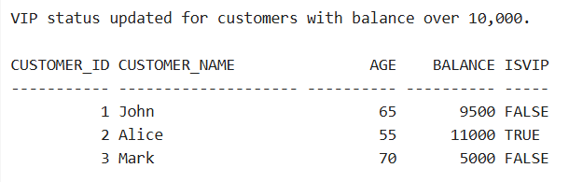

**Scenario 3:** The bank wants to send reminders to customers whose loans are due within the next 30 days.

* + **Question:** Write a PL/SQL block that fetches all loans due in the next 30 days and prints a reminder message for each customer.

SET SERVEROUTPUT ON;

DECLARE

CURSOR due_loans_cursor IS

SELECT CUSTOMER_ID, DUE_DATE

FROM LOANS

WHERE DUE_DATE BETWEEN SYSDATE AND SYSDATE + 30;

BEGIN

FOR rec IN due_loans_cursor LOOP

DBMS_OUTPUT.PUT_LINE('Reminder: Customer ' || rec.CUSTOMER_ID ||

' has a loan due on ' || TO_CHAR(rec.DUE_DATE, 'DD-MON-YYYY'));

END LOOP;

END;

/

**OUPUT:**

Reminder: Customer 1 has a loan due on 08-JUL-2025

Reminder: Customer 3 has a loan due on 18-JUL-2025